Test Report
No. SHAEC1728480201
Description
Date: 05 Jan 2018
Page 2 of 20
Test Results :
Test Part Description :
Specimen No.
SN1
SGS Sample ID
SHA17-284802.001
SHA17-284802.002
Silvery metal pin part
Black body part (mix all*)
SN2
Remarks :
(1) 1 mg/kg = 0.0001%
(2) MDL = Method Detection Limit
(3) ND = Not Detected ( < MDL )
(4) "-" = Not Regulated
RoHS Directive (EU) 2015/863 amending Annex II to Directive 2011/65/EU.
Test Method : With reference to IEC 62321-4:2013+AMD1:2017, IEC62321-5:2013, IEC62321-7-2:2017, IEC
62321-6:2015 and IEC62321-8:2017, analyzed by ICP-OES, AAS, UV-Vis and GC-MS.
Test Item(s)
Limit
Unit
MDL
2
002
4
Lead (Pb)
1000
mg/kg
mg/kg
mg/kg
mg/kg
mg/kg
mg/kg
mg/kg
mg/kg
mg/kg
mg/kg
mg/kg
mg/kg
mg/kg
mg/kg
mg/kg
mg/kg
mg/kg
mg/kg
mg/kg
mg/kg
Cadmium (Cd)
Mercury (Hg)
Hexavalent Chromium (Cr(VI))
Sum of PBBs
Monobromobiphenyl
Dibromobiphenyl
100
1000
1000
1000
-
-
-
-
-
-
-
-
-
-
2
2
8
-
5
5
5
5
5
5
5
5
5
5
-
5
ND
ND
ND
ND
ND
ND
ND
ND
ND
ND
ND
ND
ND
ND
ND
ND
ND
ND
ND
Tribromobiphenyl
Tetrabromobiphenyl
Pentabromobiphenyl
Hexabromobiphenyl
Heptabromobiphenyl
Octabromobiphenyl
Nonabromobiphenyl
Decabromobiphenyl
Sum of PBDEs
Monobromodiphenyl ether
Dibromodiphenyl ether
Tribromodiphenyl ether
Tetrabromodiphenyl ether
1000
-
-
-
-
5
5
5

Test Report
No. SHAEC1728480201
Limit.
Date: 05 Jan 2018
Page 3 of 20
Test Item(s).
Unit.
MDL
5
002.
ND
ND
ND
ND
ND
ND
ND
ND
ND
ND
Pentabromodiphenyl ether
Hexabromodiphenyl ether
Heptabromodiphenyl ether
Octabromodiphenyl ether
Nonabromodiphenyl ether
Decabromodiphenyl ether
Di-butyl Phthalate (DBP)
Benzyl Butyl Phthalate (BBP)
Di-2-Ethyl Hexyl Phthalate (DEHP)
Diisobutyl Phthalates (DIBP)
-
mg/kg
mg/kg
mg/kg
mg/kg
mg/kg
mg/kg
mg/kg
mg/kg
mg/kg
mg/kg
-
-
-
-
-
5
5
5
5
5
1000
1000
1000
1000
50
50
50
50
Notes :
(1)The maximum permissible limit is quoted from RoHS Directive (EU) 2015/863.
IEC 62321 series is equivalent to EN 62321 series
http://www.cenelec.eu/dyn/www/f?p=104:30:1742232870351101::::FSP_ORG_ID,FSP_LANG
_ID:1258637,25
(2)On 4 June 2015, Commission Directive (EU) 2015/863 was published in the Official Journal of
the European Union (OJEU) to include the phthalates BBP, DBP, DEHP and DIBP into
ANNEX II of the Rohs Recast Directive. The new law restricts each phthalate to no more than
0.1% in each homogeneous material of an electrical product.
(3)The restriction of DEHP, BBP, DBP and DIBP shall apply to medical devices, including in vitro
medical devices, and monitoring and control instruments, including industrial monitoring and
control instruments, from 22 July 2021.
(4)The restriction of DEHP, BBP, DBP and DIBP shall not apply to cables or spare parts for the
repair, the reuse, the updating of functionalities or upgrading of capacity of EEE placed on the
market before 22 July 2019, and of medical devices, including in vitro medical devices, and
monitoring and control instruments, including industrial monitoring and control
instruments, placed on the market before 22 July 2021.
(5)The restriction of DEHP, BBP and DBP shall not apply to toys which are already subject to
the restriction of DEHP, BBP and DBP through entry 51 of Annex XVII to Regulation (EC) No
1907/2006.
RoHS Directive (EU) 2015/863 amending Annex II to Directive 2011/65/EU
Test Method : With reference to IEC 62321-4:2013+AMD1:2017, IEC62321-5:2013 and IEC62321-7-1:2015,
analyzed by ICP-OES and UV-Vis .

Test Report
No. SHAEC1728480201
Limit.
Date: 05 Jan 2018
Page 4 of 20
Test Item(s).
Unit.
MDL
2
2
001.
ND
17
Cadmium (Cd)
Lead (Pb)
Mercury (Hg)
Hexavalent Chromium (Cr(VI))▼
100
1000
1000
-
mg/kg
mg/kg
mg/kg
µg/cm²
2
0.10
ND
ND
Notes :
(1)The maximum permissible limit is quoted from RoHS Directive (EU) 2015/863.
IEC 62321 series is equivalent to EN 62321 series
http://www.cenelec.eu/dyn/www/f?p=104:30:1742232870351101::::FSP_ORG_ID,FSP_LANG
_ID:1258637,25
(2)▼ = a. The sample is positive for CrVI if the CrVI concentration is greater than 0.13 μg/cm².
The sample coating is considered to contain CrVI
b. The sample is negative for CrVI if CrVI is ND (concentration less than 0.10 μg/cm²). The
coating is considered a non-CrVI based coating
c. The result between 0.10 μg/cm² and 0.13 μg/cm² is considered to be inconclusive -
unavoidable coating variations may influence the determination
Information on storage conditions and production date of the tested sample is unavailable
and thus Cr(VI) results represent status of the sample at the time of testing.
Sulfur.
Test Method : With reference to EN 14582: 2007, analysis was performed by Ion Chromatograph (IC).
Test Item(s).
Sulfur (S)
Unit.
MDL
50
002.
ND
mg/kg
Polychlorinated Naphthalenes (PCNs).
Test Method : With reference to US EPA 8081B: 2007, analysis was performed by GC-MS
Test Item(s).
Unit.
mg/kg
mg/kg
mg/kg
mg/kg
mg/kg
mg/kg
MDL
002.
ND
ND
ND
ND
ND
ND
2-Chlorinated Naphthalene
1,4-Dichlorinated Naphthalene
1,5-Dichlorinated Naphthalene
1,2-Dichlorinated Naphthalene
1,8-Dichlorinated Naphthalene
1,2,3-Trichlorinated Naphthalene
5
5
5
5
5
5

Test Report
No. SHAEC1728480201
Date: 05 Jan 2018
Page 5 of 20
Test Item(s).
Unit.
mg/kg
mg/kg
mg/kg
mg/kg
MDL
002.
ND
ND
ND
ND
1,2,3,4-Tetrachlorinated Naphthalene
5
5
5
5
1,2,3,4,6-Pentachlorinated Naphthalene
Octa-chlorinaed Naphthalene
1-Chlorinated Naphthalene
Organic-tin compounds.
Test Method : With reference to ISO 17353: 2004 with carbamate, analysis was performed by GC-MS.
Test Item(s).
Unit.
mg/kg
mg/kg
mg/kg
MDL
0.02
0.02
0.02
002.
ND
ND
Tributyl tin (TBT)
Tripropyltin (TPT)
Dibutyl tin (DBT)
ND
Alkanes C10-C13, chloro (short-chain chlorinated paraffins) (SCCP)
Test Method : With reference to ISO 18219: 2015, analysis was performed by GC-NCl-MS
Test Item(s).
Unit.
MDL
50
002.
ND
Alkanes C10-C13, chloro (short-chain chlorinated
paraffins) (SCCP)
mg/kg
Hexabromocyclododecane (HBCDD)
Test Method : With reference to US EPA 3550C: 2007, analysis was performed by GC-MS.
Test Item(s).
CAS NO.
Unit.
MDL
10
002.
ND
Hexabromocyclododecane
(HBCDD)
25637-99-4,
3194- 55-6
mg/kg
Bisphenol-A.

Test Report
No. SHAEC1728480201
Date: 05 Jan 2018
Page 6 of 20
Test Method : Extraction by organic solvent, analysis by HPLC-DAD-MS.
Test Item(s)
Bisphenol-A
Unit
MDL
1
002
ND
mg/kg
Polychlorinated Terphenyls (PCTs)
Test Method : With reference to US EPA 8082A: 2007, analysis was performed by GC-MS
Test Item(s)
Aroclor 5432
Aroclor 5442
Unit
mg/kg
mg/kg
MDL
002
ND
ND
5
5
PFOS (Perfluorooctane Sulfonates) and PFOA (Perfluorooctanoic Acid)
Test Method : With reference to US EPA 3550C: 2007, analysis was performed by HPLC-MS.
Test Item(s)
Perfluorooctanesulfonate (PFOS)^
Perfluorooctanoic Acid (PFOA)
Limit
1000
Unit
mg/kg
mg/kg
MDL
10
10
002
ND
ND
-
Notes :
(1) Max. limit specified by commission regulation (EU) No. 757/2010 amending regulation (EC) No
850/2004
(2)^ PFOS refer to Perfluorooctanesulfonic acid and its derivatives including Perfluoroctanesulfonic acid,
Perfluoroctane sulfonamide, N-Methylperfluoroctane sulfonamide, N-Ethylperfluoroctane sulfonamide,
N-Methylperfluoroctane sulfonamidoethanol and N-Ethylperfluoroctane sulfonamidoethanol.
Polycyclic aromatic hydrocarbons (PAHs).
Test Method : With reference to AfPS GS 2014:01 PAK, analysis was performed by GC-MS.
Test Item(s)
Unit
mg/kg
MDL
0.1
002
ND
Benzo(a)pyrene(BaP)
Benzo(e)pyrene(BeP)
Benzo(a)anthracene(BaA)
Benzo(b)fluoranthene(BbF)
Benzo(j)fluoranthene(BjF)
Benzo(k)fluoranthene(BkF)
mg/kg
mg/kg
mg/kg
mg/kg
mg/kg
0.1
0.1
0.1
0.1
0.1
ND
ND
ND
ND
ND

Test Report
No. SHAEC1728480201
Date: 05 Jan 2018
Unit.
Page 7 of 20
Test Item(s).
Chrysene(CHR)
MDL
0.1
002.
mg/kg
mg/kg
mg/kg
mg/kg
mg/kg
mg/kg
mg/kg
mg/kg
mg/kg
mg/kg
mg/kg
mg/kg
ND
ND
ND
ND
ND
ND
ND
ND
ND
ND
ND
ND
Dibenzo(a,h)anthracene(DBA)
Benzo(g,h,i)perylene(BPE)
Indeno(1,2,3-c,d)pyrene(IPY)
Acenaphthylene(ANY)
Acenaphthene(ANA)
Fluorene(FLU)
Phenanthrene(PHE)
Pyrene(PYR)
Anthracene(ANT)
0.1
0.1
0.1
0.1
0.1
0.1
0.1
0.1
0.1
0.1
-
Fluoranthene(FLT)
Sum of Acenaphthylene, Acenaphthene, Fluorene, Phenanthrene, Pyrene,
Anthracene, Fluoranthene
Naphthalene(NAP)
Sum of 18 PAHs
mg/kg
mg/kg
0.1
-
ND
ND

Test Report
No. SHAEC1728480201
Date: 05 Jan 2018
Page 8 of 20
Phthalates Content.
Test Method : With reference to EN 14372:2004, analysis was performed by GC-MS.
Test Item(s).
Dibutyl Phthalate (DBP)
Benzylbutyl Phthalate (BBP)
Bis-(2-ethylhexyl) Phthalate (DEHP)
Diisononyl Phthalate (DINP)
CAS NO.
84-74-2
85-68-7
Unit.
%
%
%
%
MDL
0.003
0.003
0.003
0.01
002.
ND
ND
ND
ND
117-81-7
28553-12-0
/68515-48-0
117-84-0
Di-n-octyl Phthalate (DNOP)
%
0.003
ND
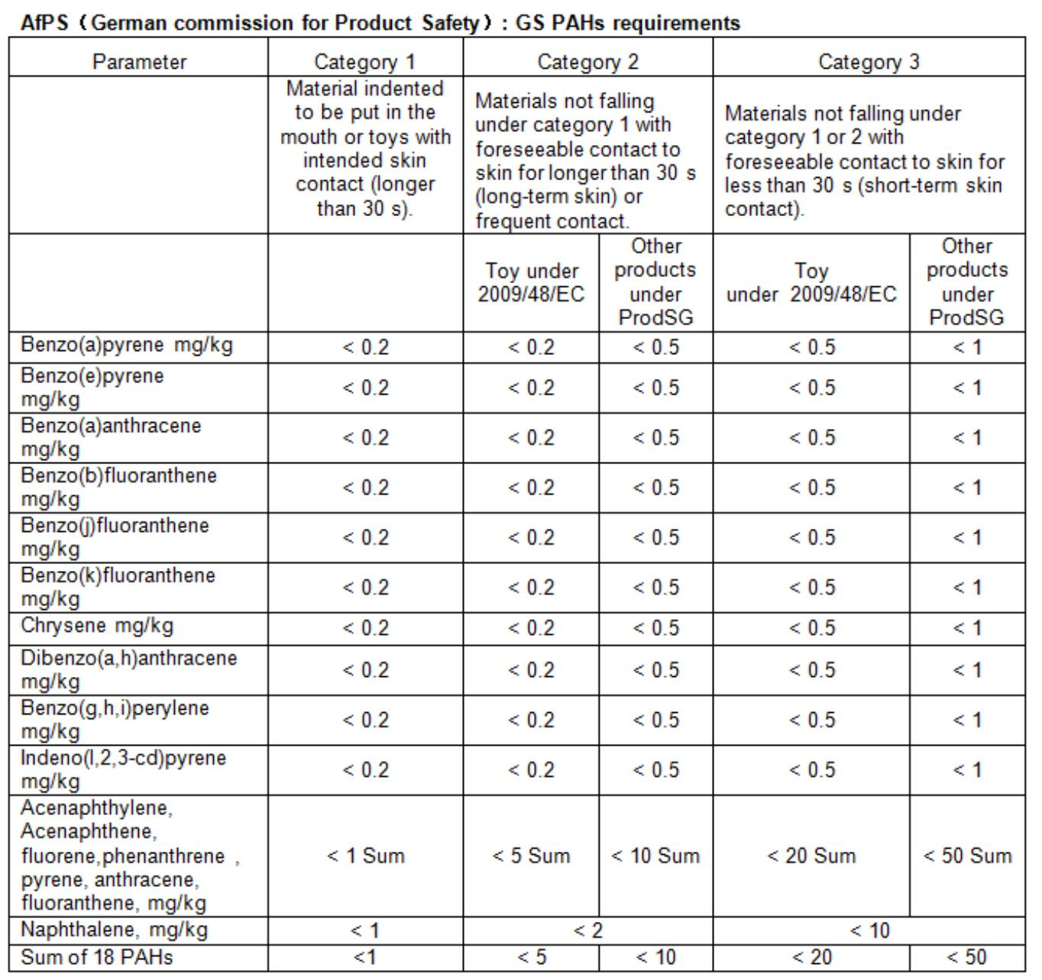

Test Report
No. SHAEC1728480201
Date: 05 Jan 2018
Page 9 of 20
Test Item(s).
Diisodecyl Phthalate (DIDP)
CAS NO.
Unit.
%
MDL
0.01
002.
ND
26761-40-0
/68515-49-1
131-11-3
84-66-2
84-69-5
131-18-0
84-61-7
84-62-8
523-31-9
27554-26-3
131-16-8
84-76-4
Dimethyl Phthalate (DMP)
Diethyl Phthalate (DEP)
%
%
%
%
%
%
%
%
%
%
%
0.003
0.003
0.003
0.003
0.003
0.003
0.003
0.01
ND
ND
ND
ND
ND
ND
ND
ND
ND
ND
ND
Diisobutyl Phthalate (DIBP)
Di-n-pentyl Phthalates (DnPP)
Dicyclohexyl Phthalate (DCHP)
Diphenyl Phthalate (DPhP)
Dibenzyl Phthalate (DBzP)
Diisooctyl Phthalate (DiOP)
Dipropyl Phthalate (DPrP)
Dinonyl Phthalate (DNP)
0.003
0.003
0.003
Di-n-hexyl Phthalate (DnHP)
84-75-3
Notes :
(1) DBP,BBP,DEHP Reference information: Entry 51 of Regulation (EC) No 552/2009 amending Annex
XVII of REACH Regulation (EC) No 1907/2006 (previously restricted under Directive 2005/84/EC):
i) Shall not be used as substances or in mixtures, in concentrations greater than 0.1 % by weight of
the plasticised material, in toys and childcare articles.
ii) Toys and childcare articles containing these phthalates in a concentration greater than 0.1 % by
weight of the plasticised material shall not be placed on the market.
Please refer to Regulation (EC) No 552/2009 to get more detail information
DINP, DNOP, DIDP Reference information: Entry 52 of Regulation (EC) No 552/2009 amending
Annex XVII of REACH Regulation (EC) No 1907/2006 (previously restricted under Directive
2005/84/EC).
i) Shall not be used as substances or in mixtures, in concentrations greater than 0.1 % by weight of
the plasticised material, in toys and childcare articles which can be placed in the mouth by
children.
ii) Such toys and childcare articles containing these phthalates in a concentration greater than 0.1 %
by weight of the plasticised material shall not be placed on the market.
Please refer to Regulation (EC) No 552/2009 to get more detail information
Polychlorinated Biphenyls (PCBs).
Test Method : With reference to US EPA 8082A: 2007, analysis was performed by GC-MS
Test Item(s)
2,4,4’-Trichlorobiphenyl (PCB 28)
CAS NO.
7012-37-5
Unit
mg/kg
MDL
0.5
002
ND
2,2’,5,5’-Tetrachloro-biphenyl (PCB 52)
2,2’,4,5,5’-Pentachloro-biphenyl (PCB 101)
35693-99-3
37680-73-2
mg/kg
mg/kg
0.5
0.5
ND
ND

Test Report
No. SHAEC1728480201
Date: 05 Jan 2018
Page 10 of 20
Test Item(s).
CAS NO.
Unit.
mg/kg
mg/kg
mg/kg
mg/kg
MDL
0.5
0.5
0.5
0.5
002.
ND
ND
ND
ND
2,3’,4,4’,5-Pentachlorobiphenyl (PCB 118)
2,2’,3,4,4’,5’-Hexachloro-biphenyl (PCB 138)
2,2’,4,4’,5,5’-Hexachloro-biphenyl (PCB 153)
2,2’,3,4,4’,5,5’-Heptachlorobiphenyl (PCB 180)
31508-00-6
35065-28-2
35065-27-1
35065-29-3
Benzotriazole UV Absorbant
Test Method : With reference to US EPA 3550C: 2007, analysis was performed by GC-MS.
Test Item(s).
Unit.
mg/kg
MDL
5
002.
ND
2-(3,5-Di-tert-butyl-2-hydroxyphenyl) benzotriazole (UV-320) (CAS No:
3846-71-7)
2-(3’,5’-Di-tert-butyl-2’-hydroxyphenyl)-5-chloro benzotriazole (UV-327) (CAS
No: 3864-99-1)
2-(2’-hydroxy-3’,5’-di-tert- amylphenyl) benzotriazole (UV-328) (CAS No:
25973-55-1)
mg/kg
mg/kg
mg/kg
5
5
5
ND
ND
ND
TinUVin 350 (UV-350) (CAS No: 36437-37-3)
*The sample(s) was/were analyzed on behalf of the applicant as mixing sample in one testing. The
above result(s) was/were only given as the informality value and only for reference.

Test Report
No. SHAEC1728480201
Date: 05 Jan 2018
Page 11 of 20
ATTACHMENTS
Pb/Cd/Hg/Cr⁶⁺/PBBs/PBDEs Testing Flow Chart
1) Name of the person who made testing: Meria Jin/Gary Xu/ Xiaolong Yang/Sielina Song
2) Name of the person in charge of testing: Jan Shi/Jessy Huang/Luna Xu/Shara Wang
3) These samples were dissolved totally by pre-conditioning method according to below flow chart.
6+
(Cr and PBBs/PBDEs test method excluded)
Sample Preparation
Sample Measurement
Cr⁶⁺
Pb/Cd/Hg/Cr
Acid digestion with
PBBs/PBDEs
Sample solvent
Nonmetallic
material
Metallic
material
microwave /
hotplate
extraction
ABS/PC/PVC
Others
Concentration/
Dilution of
extraction solution
Boiling water
extraction
Filtration
Dissolving by
ultrasonicatio
Digesting at
150~160°C
Adding 1,5-
diphenylcarb
azide for
Solution
Residue
Filtration
GC-MS
DATA
Digesting at
60°C by
ultrasonicatio
Separating to
get aqueous
phase
color
1) Alkali Fusion /
Dry Ashing
2) Acid to
UV-Vis.
DATA
pH adjustment
ICP-OES/AAS
DATA
Adding 1,5-
diphenylcarbazide
for color
UV-Vis
DATA
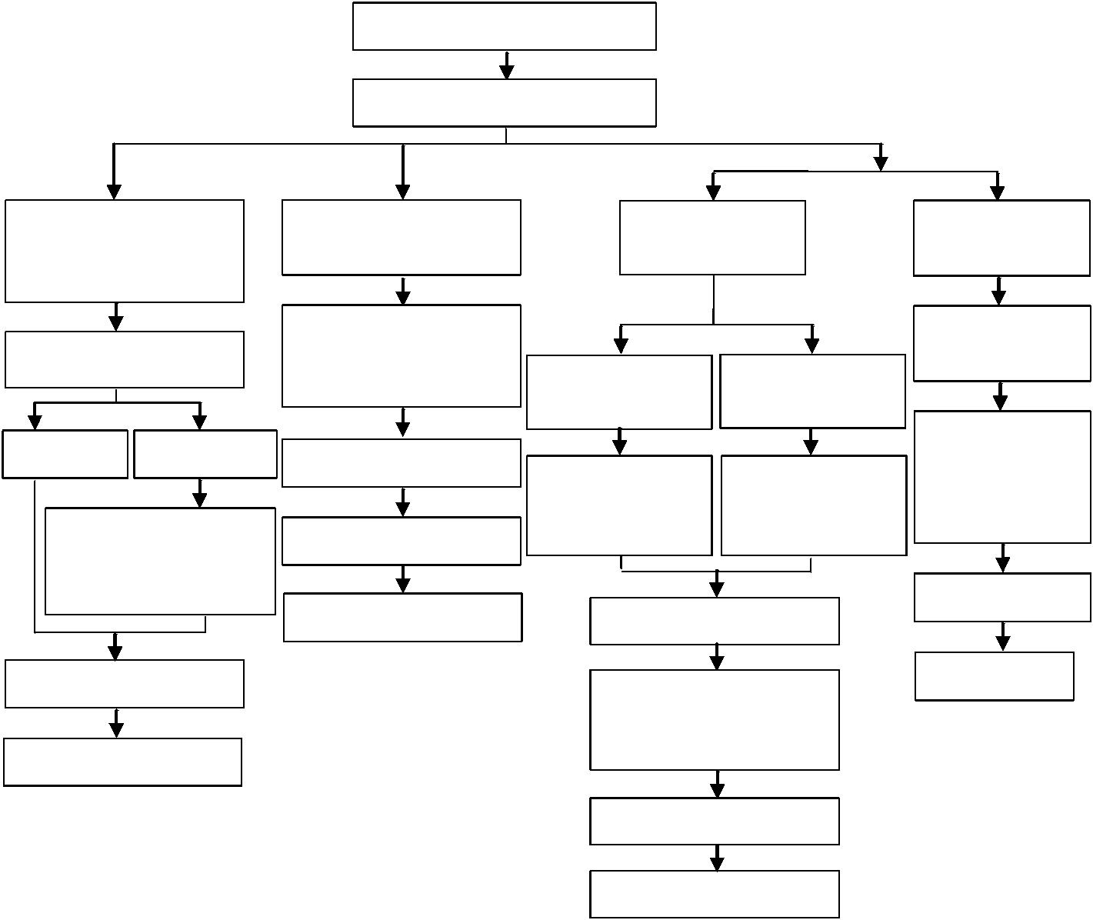

Test Report
No. SHAEC1728480201
Date: 05 Jan 2018
Page 12 of 20
ATTACHMENTS
Phthalates Testing Flow Chart
1) Name of the person who made testing: Sherlock Gao
2) Name of the person in charge of testing: Jessy Huang
Sample cutting/preparation
Sample measurement
Solvent extraction
Concentration/Dilution
Filtration
GC-MS
DATA
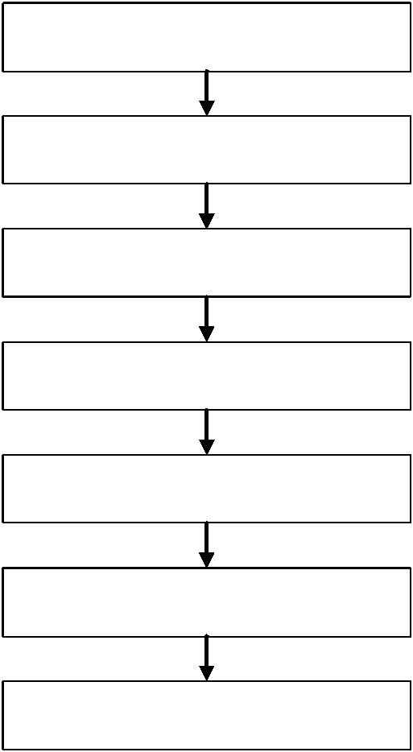

Test Report
No. SHAEC1728480201
Date: 05 Jan 2018
Page 13 of 20
ATTACHMENTS
HBCDD Testing Flow Chart
1) Name of the person who made testing: Gary Xu
2) Name of the person in charge of testing: Jessy Huang
Sample cutting/preparation
Sample measurement
Solvent extraction
Concentration/Dilution
Filtration
GC-MS
DATA

Test Report
No. SHAEC1728480201
Date: 05 Jan 2018
Page 14 of 20
ATTACHMENTS
PFOS/PFOA Testing Flow Chart
1) Name of the person who made testing: Jane Yang
2) Name of the person in charge of testing: Myra Ma
Sample cutting/preparation
Sample measurement
Solvent extraction
Concentration/Dilution
Filtration
LC-MS
DATA

Test Report
No. SHAEC1728480201
Date: 05 Jan 2018
Page 15 of 20
ATTACHMENTS
BPA Testing Flow Chart
1) Name of the person who made testing: Alfred Chen
2) Name of the person in charge of testing: Judy Li
Sample cutting/preparation
Sample measurement
Solvent extraction
Concentration/Dilution
Filtration
HPLC-DAD-MS/LC_MS
DATA
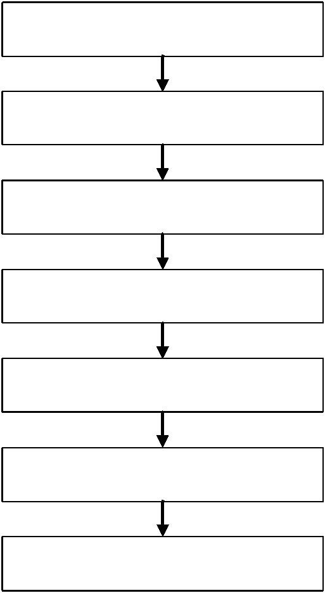

Test Report
No. SHAEC1728480201
Date: 05 Jan 2018
Page 16 of 20
ATTACHMENTS
PAHs Testing Flow Chart
1) Name of the person who made testing: Sherlock Gao
2) Name of the person in charge of testing: Jessy Huang
Sample cutting/preparation
Sample measurement
Solvent extraction
Concentration/Dilution
Filtration
GC-MS
DATA

Test Report
No. SHAEC1728480201
Date: 05 Jan 2018
Page 17 of 20
ATTACHMENTS
PCB/ PCT/ PCN Testing Flow Chart
1) Name of the person who made testing: Jenny Zhang
2) Name of the person in charge of testing: Zirco Yu
Sample cutting/preparation
Sample measurement
Solvent extraction
Concentration/Dilution
Filtration
GC-MS
DATA

Test Report
No. SHAEC1728480201
Date: 05 Jan 2018
Page 18 of 20
ATTACHMENTS
Organotin Testing Flow Chart
1) Name of the person who made testing: Alex Deng
2) Name of the person in charge of testing: Jessy Huang
Sample cutting/preparation
Sample measurement
Solvent extraction
Derivatization
Liquid-liquid extraction
Concentration/Dilution
Filtration
GC-MS
DATA
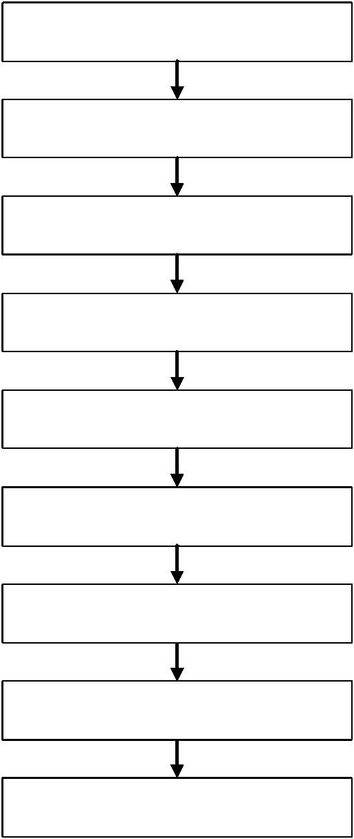

Test Report
No. SHAEC1728480201
Date: 05 Jan 2018
Page 19 of 20
ATTACHMENTS
Benzotriazole Testing Flow Chart
1) Name of the person who made testing: Sherlock Gao
2) Name of the person in charge of testing: Jessy Huang
Sample cutting/preparation
Sample measurement
Solvent extraction
Concentration/Dilution
Filtration
GC-MS
DATA

Test Report
No. SHAEC1728480201
Date: 05 Jan 2018
Page 20 of 20
Sample photo:
SHA17-284802.001
SHA17-284802.002
SGS authenticate the photo on original report only
*** End of Report ***
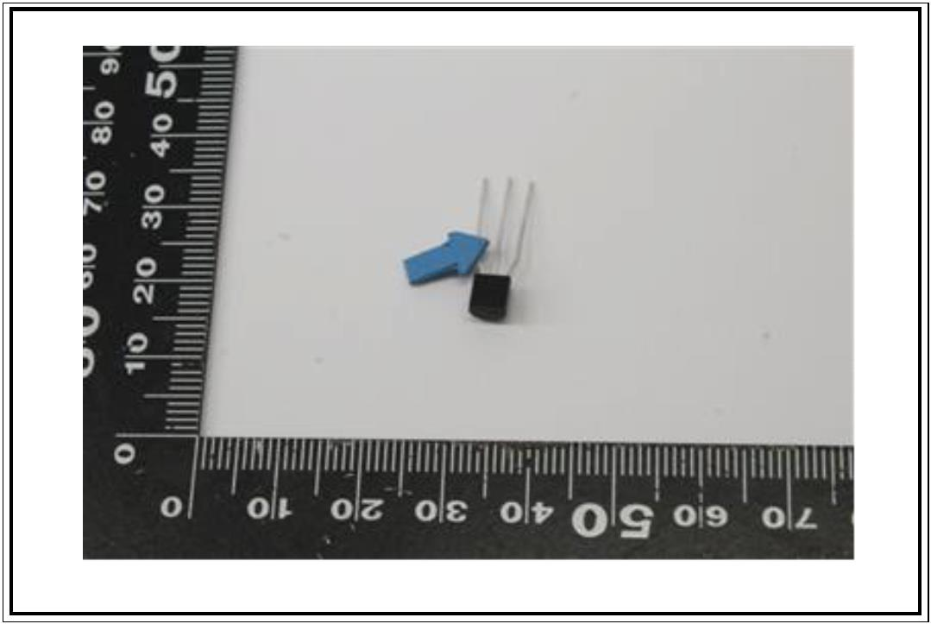
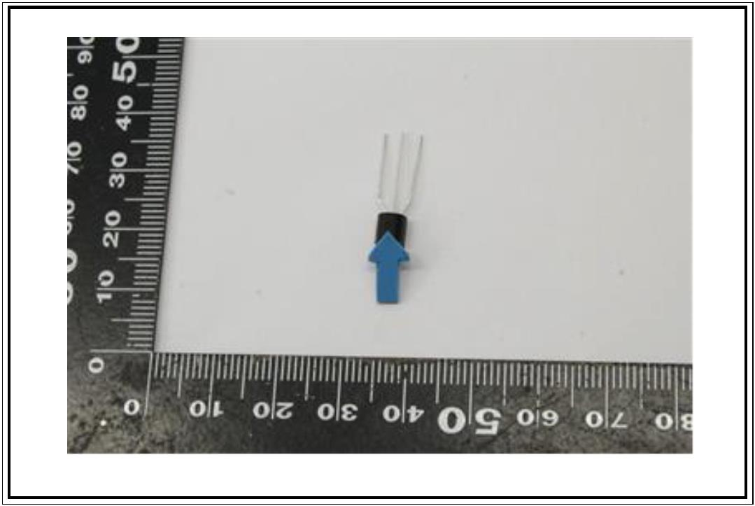

Test Report
No. SHAEC1728480201
Description
Date: 05 Jan 2018
Page 2 of 20
Test Results :
Test Part Description :
Specimen No.
SN1
SGS Sample ID
SHA17-284802.001
SHA17-284802.002
Silvery metal pin part
Black body part (mix all*)
SN2
Remarks :
(1) 1 mg/kg = 0.0001%
(2) MDL = Method Detection Limit
(3) ND = Not Detected ( < MDL )
(4) "-" = Not Regulated
RoHS Directive (EU) 2015/863 amending Annex II to Directive 2011/65/EU.
Test Method : With reference to IEC 62321-4:2013+AMD1:2017, IEC62321-5:2013, IEC62321-7-2:2017, IEC
62321-6:2015 and IEC62321-8:2017, analyzed by ICP-OES, AAS, UV-Vis and GC-MS.
Test Item(s)
Limit
Unit
MDL
2
002
4
Lead (Pb)
1000
mg/kg
mg/kg
mg/kg
mg/kg
mg/kg
mg/kg
mg/kg
mg/kg
mg/kg
mg/kg
mg/kg
mg/kg
mg/kg
mg/kg
mg/kg
mg/kg
mg/kg
mg/kg
mg/kg
mg/kg
Cadmium (Cd)
Mercury (Hg)
Hexavalent Chromium (Cr(VI))
Sum of PBBs
Monobromobiphenyl
Dibromobiphenyl
100
1000
1000
1000
-
-
-
-
-
-
-
-
-
-
2
2
8
-
5
5
5
5
5
5
5
5
5
5
-
5
ND
ND
ND
ND
ND
ND
ND
ND
ND
ND
ND
ND
ND
ND
ND
ND
ND
ND
ND
Tribromobiphenyl
Tetrabromobiphenyl
Pentabromobiphenyl
Hexabromobiphenyl
Heptabromobiphenyl
Octabromobiphenyl
Nonabromobiphenyl
Decabromobiphenyl
Sum of PBDEs
Monobromodiphenyl ether
Dibromodiphenyl ether
Tribromodiphenyl ether
Tetrabromodiphenyl ether
1000
-
-
-
-
5
5
5

Test Report
No. SHAEC1728480201
Limit.
Date: 05 Jan 2018
Page 3 of 20
Test Item(s).
Unit.
MDL
5
002.
ND
ND
ND
ND
ND
ND
ND
ND
ND
ND
Pentabromodiphenyl ether
Hexabromodiphenyl ether
Heptabromodiphenyl ether
Octabromodiphenyl ether
Nonabromodiphenyl ether
Decabromodiphenyl ether
Di-butyl Phthalate (DBP)
Benzyl Butyl Phthalate (BBP)
Di-2-Ethyl Hexyl Phthalate (DEHP)
Diisobutyl Phthalates (DIBP)
-
mg/kg
mg/kg
mg/kg
mg/kg
mg/kg
mg/kg
mg/kg
mg/kg
mg/kg
mg/kg
-
-
-
-
-
5
5
5
5
5
1000
1000
1000
1000
50
50
50
50
Notes :
(1)The maximum permissible limit is quoted from RoHS Directive (EU) 2015/863.
IEC 62321 series is equivalent to EN 62321 series
http://www.cenelec.eu/dyn/www/f?p=104:30:1742232870351101::::FSP_ORG_ID,FSP_LANG
_ID:1258637,25
(2)On 4 June 2015, Commission Directive (EU) 2015/863 was published in the Official Journal of
the European Union (OJEU) to include the phthalates BBP, DBP, DEHP and DIBP into
ANNEX II of the Rohs Recast Directive. The new law restricts each phthalate to no more than
0.1% in each homogeneous material of an electrical product.
(3)The restriction of DEHP, BBP, DBP and DIBP shall apply to medical devices, including in vitro
medical devices, and monitoring and control instruments, including industrial monitoring and
control instruments, from 22 July 2021.
(4)The restriction of DEHP, BBP, DBP and DIBP shall not apply to cables or spare parts for the
repair, the reuse, the updating of functionalities or upgrading of capacity of EEE placed on the
market before 22 July 2019, and of medical devices, including in vitro medical devices, and
monitoring and control instruments, including industrial monitoring and control
instruments, placed on the market before 22 July 2021.
(5)The restriction of DEHP, BBP and DBP shall not apply to toys which are already subject to
the restriction of DEHP, BBP and DBP through entry 51 of Annex XVII to Regulation (EC) No
1907/2006.
RoHS Directive (EU) 2015/863 amending Annex II to Directive 2011/65/EU
Test Method : With reference to IEC 62321-4:2013+AMD1:2017, IEC62321-5:2013 and IEC62321-7-1:2015,
analyzed by ICP-OES and UV-Vis .

Test Report
No. SHAEC1728480201
Limit.
Date: 05 Jan 2018
Page 4 of 20
Test Item(s).
Unit.
MDL
2
2
001.
ND
17
Cadmium (Cd)
Lead (Pb)
Mercury (Hg)
Hexavalent Chromium (Cr(VI))▼
100
1000
1000
-
mg/kg
mg/kg
mg/kg
µg/cm²
2
0.10
ND
ND
Notes :
(1)The maximum permissible limit is quoted from RoHS Directive (EU) 2015/863.
IEC 62321 series is equivalent to EN 62321 series
http://www.cenelec.eu/dyn/www/f?p=104:30:1742232870351101::::FSP_ORG_ID,FSP_LANG
_ID:1258637,25
(2)▼ = a. The sample is positive for CrVI if the CrVI concentration is greater than 0.13 μg/cm².
The sample coating is considered to contain CrVI
b. The sample is negative for CrVI if CrVI is ND (concentration less than 0.10 μg/cm²). The
coating is considered a non-CrVI based coating
c. The result between 0.10 μg/cm² and 0.13 μg/cm² is considered to be inconclusive -
unavoidable coating variations may influence the determination
Information on storage conditions and production date of the tested sample is unavailable
and thus Cr(VI) results represent status of the sample at the time of testing.
Sulfur.
Test Method : With reference to EN 14582: 2007, analysis was performed by Ion Chromatograph (IC).
Test Item(s).
Sulfur (S)
Unit.
MDL
50
002.
ND
mg/kg
Polychlorinated Naphthalenes (PCNs).
Test Method : With reference to US EPA 8081B: 2007, analysis was performed by GC-MS
Test Item(s).
Unit.
mg/kg
mg/kg
mg/kg
mg/kg
mg/kg
mg/kg
MDL
002.
ND
ND
ND
ND
ND
ND
2-Chlorinated Naphthalene
1,4-Dichlorinated Naphthalene
1,5-Dichlorinated Naphthalene
1,2-Dichlorinated Naphthalene
1,8-Dichlorinated Naphthalene
1,2,3-Trichlorinated Naphthalene
5
5
5
5
5
5

Test Report
No. SHAEC1728480201
Date: 05 Jan 2018
Page 5 of 20
Test Item(s).
Unit.
mg/kg
mg/kg
mg/kg
mg/kg
MDL
002.
ND
ND
ND
ND
1,2,3,4-Tetrachlorinated Naphthalene
5
5
5
5
1,2,3,4,6-Pentachlorinated Naphthalene
Octa-chlorinaed Naphthalene
1-Chlorinated Naphthalene
Organic-tin compounds.
Test Method : With reference to ISO 17353: 2004 with carbamate, analysis was performed by GC-MS.
Test Item(s).
Unit.
mg/kg
mg/kg
mg/kg
MDL
0.02
0.02
0.02
002.
ND
ND
Tributyl tin (TBT)
Tripropyltin (TPT)
Dibutyl tin (DBT)
ND
Alkanes C10-C13, chloro (short-chain chlorinated paraffins) (SCCP)
Test Method : With reference to ISO 18219: 2015, analysis was performed by GC-NCl-MS
Test Item(s).
Unit.
MDL
50
002.
ND
Alkanes C10-C13, chloro (short-chain chlorinated
paraffins) (SCCP)
mg/kg
Hexabromocyclododecane (HBCDD)
Test Method : With reference to US EPA 3550C: 2007, analysis was performed by GC-MS.
Test Item(s).
CAS NO.
Unit.
MDL
10
002.
ND
Hexabromocyclododecane
(HBCDD)
25637-99-4,
3194- 55-6
mg/kg
Bisphenol-A.

Test Report
No. SHAEC1728480201
Date: 05 Jan 2018
Page 6 of 20
Test Method : Extraction by organic solvent, analysis by HPLC-DAD-MS.
Test Item(s)
Bisphenol-A
Unit
MDL
1
002
ND
mg/kg
Polychlorinated Terphenyls (PCTs)
Test Method : With reference to US EPA 8082A: 2007, analysis was performed by GC-MS
Test Item(s)
Aroclor 5432
Aroclor 5442
Unit
mg/kg
mg/kg
MDL
002
ND
ND
5
5
PFOS (Perfluorooctane Sulfonates) and PFOA (Perfluorooctanoic Acid)
Test Method : With reference to US EPA 3550C: 2007, analysis was performed by HPLC-MS.
Test Item(s)
Perfluorooctanesulfonate (PFOS)^
Perfluorooctanoic Acid (PFOA)
Limit
1000
Unit
mg/kg
mg/kg
MDL
10
10
002
ND
ND
-
Notes :
(1) Max. limit specified by commission regulation (EU) No. 757/2010 amending regulation (EC) No
850/2004
(2)^ PFOS refer to Perfluorooctanesulfonic acid and its derivatives including Perfluoroctanesulfonic acid,
Perfluoroctane sulfonamide, N-Methylperfluoroctane sulfonamide, N-Ethylperfluoroctane sulfonamide,
N-Methylperfluoroctane sulfonamidoethanol and N-Ethylperfluoroctane sulfonamidoethanol.
Polycyclic aromatic hydrocarbons (PAHs).
Test Method : With reference to AfPS GS 2014:01 PAK, analysis was performed by GC-MS.
Test Item(s)
Unit
mg/kg
MDL
0.1
002
ND
Benzo(a)pyrene(BaP)
Benzo(e)pyrene(BeP)
Benzo(a)anthracene(BaA)
Benzo(b)fluoranthene(BbF)
Benzo(j)fluoranthene(BjF)
Benzo(k)fluoranthene(BkF)
mg/kg
mg/kg
mg/kg
mg/kg
mg/kg
0.1
0.1
0.1
0.1
0.1
ND
ND
ND
ND
ND

Test Report
No. SHAEC1728480201
Date: 05 Jan 2018
Unit.
Page 7 of 20
Test Item(s).
Chrysene(CHR)
MDL
0.1
002.
mg/kg
mg/kg
mg/kg
mg/kg
mg/kg
mg/kg
mg/kg
mg/kg
mg/kg
mg/kg
mg/kg
mg/kg
ND
ND
ND
ND
ND
ND
ND
ND
ND
ND
ND
ND
Dibenzo(a,h)anthracene(DBA)
Benzo(g,h,i)perylene(BPE)
Indeno(1,2,3-c,d)pyrene(IPY)
Acenaphthylene(ANY)
Acenaphthene(ANA)
Fluorene(FLU)
Phenanthrene(PHE)
Pyrene(PYR)
Anthracene(ANT)
0.1
0.1
0.1
0.1
0.1
0.1
0.1
0.1
0.1
0.1
-
Fluoranthene(FLT)
Sum of Acenaphthylene, Acenaphthene, Fluorene, Phenanthrene, Pyrene,
Anthracene, Fluoranthene
Naphthalene(NAP)
Sum of 18 PAHs
mg/kg
mg/kg
0.1
-
ND
ND

Test Report
No. SHAEC1728480201
Date: 05 Jan 2018
Page 8 of 20
Phthalates Content.
Test Method : With reference to EN 14372:2004, analysis was performed by GC-MS.
Test Item(s).
Dibutyl Phthalate (DBP)
Benzylbutyl Phthalate (BBP)
Bis-(2-ethylhexyl) Phthalate (DEHP)
Diisononyl Phthalate (DINP)
CAS NO.
84-74-2
85-68-7
Unit.
%
%
%
%
MDL
0.003
0.003
0.003
0.01
002.
ND
ND
ND
ND
117-81-7
28553-12-0
/68515-48-0
117-84-0
Di-n-octyl Phthalate (DNOP)
%
0.003
ND

Test Report
No. SHAEC1728480201
Date: 05 Jan 2018
Page 9 of 20
Test Item(s).
Diisodecyl Phthalate (DIDP)
CAS NO.
Unit.
%
MDL
0.01
002.
ND
26761-40-0
/68515-49-1
131-11-3
84-66-2
84-69-5
131-18-0
84-61-7
84-62-8
523-31-9
27554-26-3
131-16-8
84-76-4
Dimethyl Phthalate (DMP)
Diethyl Phthalate (DEP)
%
%
%
%
%
%
%
%
%
%
%
0.003
0.003
0.003
0.003
0.003
0.003
0.003
0.01
ND
ND
ND
ND
ND
ND
ND
ND
ND
ND
ND
Diisobutyl Phthalate (DIBP)
Di-n-pentyl Phthalates (DnPP)
Dicyclohexyl Phthalate (DCHP)
Diphenyl Phthalate (DPhP)
Dibenzyl Phthalate (DBzP)
Diisooctyl Phthalate (DiOP)
Dipropyl Phthalate (DPrP)
Dinonyl Phthalate (DNP)
0.003
0.003
0.003
Di-n-hexyl Phthalate (DnHP)
84-75-3
Notes :
(1) DBP,BBP,DEHP Reference information: Entry 51 of Regulation (EC) No 552/2009 amending Annex
XVII of REACH Regulation (EC) No 1907/2006 (previously restricted under Directive 2005/84/EC):
i) Shall not be used as substances or in mixtures, in concentrations greater than 0.1 % by weight of
the plasticised material, in toys and childcare articles.
ii) Toys and childcare articles containing these phthalates in a concentration greater than 0.1 % by
weight of the plasticised material shall not be placed on the market.
Please refer to Regulation (EC) No 552/2009 to get more detail information
DINP, DNOP, DIDP Reference information: Entry 52 of Regulation (EC) No 552/2009 amending
Annex XVII of REACH Regulation (EC) No 1907/2006 (previously restricted under Directive
2005/84/EC).
i) Shall not be used as substances or in mixtures, in concentrations greater than 0.1 % by weight of
the plasticised material, in toys and childcare articles which can be placed in the mouth by
children.
ii) Such toys and childcare articles containing these phthalates in a concentration greater than 0.1 %
by weight of the plasticised material shall not be placed on the market.
Please refer to Regulation (EC) No 552/2009 to get more detail information
Polychlorinated Biphenyls (PCBs).
Test Method : With reference to US EPA 8082A: 2007, analysis was performed by GC-MS
Test Item(s)
2,4,4’-Trichlorobiphenyl (PCB 28)
CAS NO.
7012-37-5
Unit
mg/kg
MDL
0.5
002
ND
2,2’,5,5’-Tetrachloro-biphenyl (PCB 52)
2,2’,4,5,5’-Pentachloro-biphenyl (PCB 101)
35693-99-3
37680-73-2
mg/kg
mg/kg
0.5
0.5
ND
ND

Test Report
No. SHAEC1728480201
Date: 05 Jan 2018
Page 10 of 20
Test Item(s).
CAS NO.
Unit.
mg/kg
mg/kg
mg/kg
mg/kg
MDL
0.5
0.5
0.5
0.5
002.
ND
ND
ND
ND
2,3’,4,4’,5-Pentachlorobiphenyl (PCB 118)
2,2’,3,4,4’,5’-Hexachloro-biphenyl (PCB 138)
2,2’,4,4’,5,5’-Hexachloro-biphenyl (PCB 153)
2,2’,3,4,4’,5,5’-Heptachlorobiphenyl (PCB 180)
31508-00-6
35065-28-2
35065-27-1
35065-29-3
Benzotriazole UV Absorbant
Test Method : With reference to US EPA 3550C: 2007, analysis was performed by GC-MS.
Test Item(s).
Unit.
mg/kg
MDL
5
002.
ND
2-(3,5-Di-tert-butyl-2-hydroxyphenyl) benzotriazole (UV-320) (CAS No:
3846-71-7)
2-(3’,5’-Di-tert-butyl-2’-hydroxyphenyl)-5-chloro benzotriazole (UV-327) (CAS
No: 3864-99-1)
2-(2’-hydroxy-3’,5’-di-tert- amylphenyl) benzotriazole (UV-328) (CAS No:
25973-55-1)
mg/kg
mg/kg
mg/kg
5
5
5
ND
ND
ND
TinUVin 350 (UV-350) (CAS No: 36437-37-3)
*The sample(s) was/were analyzed on behalf of the applicant as mixing sample in one testing. The
above result(s) was/were only given as the informality value and only for reference.

Test Report
No. SHAEC1728480201
Date: 05 Jan 2018
Page 11 of 20
ATTACHMENTS
Pb/Cd/Hg/Cr⁶⁺/PBBs/PBDEs Testing Flow Chart
1) Name of the person who made testing: Meria Jin/Gary Xu/ Xiaolong Yang/Sielina Song
2) Name of the person in charge of testing: Jan Shi/Jessy Huang/Luna Xu/Shara Wang
3) These samples were dissolved totally by pre-conditioning method according to below flow chart.
6+
(Cr and PBBs/PBDEs test method excluded)
Sample Preparation
Sample Measurement
Cr⁶⁺
Pb/Cd/Hg/Cr
Acid digestion with
PBBs/PBDEs
Sample solvent
Nonmetallic
material
Metallic
material
microwave /
hotplate
extraction
ABS/PC/PVC
Others
Concentration/
Dilution of
extraction solution
Boiling water
extraction
Filtration
Dissolving by
ultrasonicatio
Digesting at
150~160°C
Adding 1,5-
diphenylcarb
azide for
Solution
Residue
Filtration
GC-MS
DATA
Digesting at
60°C by
ultrasonicatio
Separating to
get aqueous
phase
color
1) Alkali Fusion /
Dry Ashing
2) Acid to
UV-Vis.
DATA
pH adjustment
ICP-OES/AAS
DATA
Adding 1,5-
diphenylcarbazide
for color
UV-Vis
DATA

Test Report
No. SHAEC1728480201
Date: 05 Jan 2018
Page 12 of 20
ATTACHMENTS
Phthalates Testing Flow Chart
1) Name of the person who made testing: Sherlock Gao
2) Name of the person in charge of testing: Jessy Huang
Sample cutting/preparation
Sample measurement
Solvent extraction
Concentration/Dilution
Filtration
GC-MS
DATA

Test Report
No. SHAEC1728480201
Date: 05 Jan 2018
Page 13 of 20
ATTACHMENTS
HBCDD Testing Flow Chart
1) Name of the person who made testing: Gary Xu
2) Name of the person in charge of testing: Jessy Huang
Sample cutting/preparation
Sample measurement
Solvent extraction
Concentration/Dilution
Filtration
GC-MS
DATA

Test Report
No. SHAEC1728480201
Date: 05 Jan 2018
Page 14 of 20
ATTACHMENTS
PFOS/PFOA Testing Flow Chart
1) Name of the person who made testing: Jane Yang
2) Name of the person in charge of testing: Myra Ma
Sample cutting/preparation
Sample measurement
Solvent extraction
Concentration/Dilution
Filtration
LC-MS
DATA

Test Report
No. SHAEC1728480201
Date: 05 Jan 2018
Page 15 of 20
ATTACHMENTS
BPA Testing Flow Chart
1) Name of the person who made testing: Alfred Chen
2) Name of the person in charge of testing: Judy Li
Sample cutting/preparation
Sample measurement
Solvent extraction
Concentration/Dilution
Filtration
HPLC-DAD-MS/LC_MS
DATA

Test Report
No. SHAEC1728480201
Date: 05 Jan 2018
Page 16 of 20
ATTACHMENTS
PAHs Testing Flow Chart
1) Name of the person who made testing: Sherlock Gao
2) Name of the person in charge of testing: Jessy Huang
Sample cutting/preparation
Sample measurement
Solvent extraction
Concentration/Dilution
Filtration
GC-MS
DATA

Test Report
No. SHAEC1728480201
Date: 05 Jan 2018
Page 17 of 20
ATTACHMENTS
PCB/ PCT/ PCN Testing Flow Chart
1) Name of the person who made testing: Jenny Zhang
2) Name of the person in charge of testing: Zirco Yu
Sample cutting/preparation
Sample measurement
Solvent extraction
Concentration/Dilution
Filtration
GC-MS
DATA

Test Report
No. SHAEC1728480201
Date: 05 Jan 2018
Page 18 of 20
ATTACHMENTS
Organotin Testing Flow Chart
1) Name of the person who made testing: Alex Deng
2) Name of the person in charge of testing: Jessy Huang
Sample cutting/preparation
Sample measurement
Solvent extraction
Derivatization
Liquid-liquid extraction
Concentration/Dilution
Filtration
GC-MS
DATA

Test Report
No. SHAEC1728480201
Date: 05 Jan 2018
Page 19 of 20
ATTACHMENTS
Benzotriazole Testing Flow Chart
1) Name of the person who made testing: Sherlock Gao
2) Name of the person in charge of testing: Jessy Huang
Sample cutting/preparation
Sample measurement
Solvent extraction
Concentration/Dilution
Filtration
GC-MS
DATA

Test Report
No. SHAEC1728480201
Date: 05 Jan 2018
Page 20 of 20
Sample photo:
SHA17-284802.001
SHA17-284802.002
SGS authenticate the photo on original report only
*** End of Report ***

Test Report
No. SHAEC1728480201
Description
Date: 05 Jan 2018
Page 2 of 20
Test Results :
Test Part Description :
Specimen No.
SN1
SGS Sample ID
SHA17-284802.001
SHA17-284802.002
Silvery metal pin part
Black body part (mix all*)
SN2
Remarks :
(1) 1 mg/kg = 0.0001%
(2) MDL = Method Detection Limit
(3) ND = Not Detected ( < MDL )
(4) "-" = Not Regulated
RoHS Directive (EU) 2015/863 amending Annex II to Directive 2011/65/EU.
Test Method : With reference to IEC 62321-4:2013+AMD1:2017, IEC62321-5:2013, IEC62321-7-2:2017, IEC
62321-6:2015 and IEC62321-8:2017, analyzed by ICP-OES, AAS, UV-Vis and GC-MS.
Test Item(s)
Limit
Unit
MDL
2
002
4
Lead (Pb)
1000
mg/kg
mg/kg
mg/kg
mg/kg
mg/kg
mg/kg
mg/kg
mg/kg
mg/kg
mg/kg
mg/kg
mg/kg
mg/kg
mg/kg
mg/kg
mg/kg
mg/kg
mg/kg
mg/kg
mg/kg
Cadmium (Cd)
Mercury (Hg)
Hexavalent Chromium (Cr(VI))
Sum of PBBs
Monobromobiphenyl
Dibromobiphenyl
100
1000
1000
1000
-
-
-
-
-
-
-
-
-
-
2
2
8
-
5
5
5
5
5
5
5
5
5
5
-
5
ND
ND
ND
ND
ND
ND
ND
ND
ND
ND
ND
ND
ND
ND
ND
ND
ND
ND
ND
Tribromobiphenyl
Tetrabromobiphenyl
Pentabromobiphenyl
Hexabromobiphenyl
Heptabromobiphenyl
Octabromobiphenyl
Nonabromobiphenyl
Decabromobiphenyl
Sum of PBDEs
Monobromodiphenyl ether
Dibromodiphenyl ether
Tribromodiphenyl ether
Tetrabromodiphenyl ether
1000
-
-
-
-
5
5
5

Test Report
No. SHAEC1728480201
Limit.
Date: 05 Jan 2018
Page 3 of 20
Test Item(s).
Unit.
MDL
5
002.
ND
ND
ND
ND
ND
ND
ND
ND
ND
ND
Pentabromodiphenyl ether
Hexabromodiphenyl ether
Heptabromodiphenyl ether
Octabromodiphenyl ether
Nonabromodiphenyl ether
Decabromodiphenyl ether
Di-butyl Phthalate (DBP)
Benzyl Butyl Phthalate (BBP)
Di-2-Ethyl Hexyl Phthalate (DEHP)
Diisobutyl Phthalates (DIBP)
-
mg/kg
mg/kg
mg/kg
mg/kg
mg/kg
mg/kg
mg/kg
mg/kg
mg/kg
mg/kg
-
-
-
-
-
5
5
5
5
5
1000
1000
1000
1000
50
50
50
50
Notes :
(1)The maximum permissible limit is quoted from RoHS Directive (EU) 2015/863.
IEC 62321 series is equivalent to EN 62321 series
http://www.cenelec.eu/dyn/www/f?p=104:30:1742232870351101::::FSP_ORG_ID,FSP_LANG
_ID:1258637,25
(2)On 4 June 2015, Commission Directive (EU) 2015/863 was published in the Official Journal of
the European Union (OJEU) to include the phthalates BBP, DBP, DEHP and DIBP into
ANNEX II of the Rohs Recast Directive. The new law restricts each phthalate to no more than
0.1% in each homogeneous material of an electrical product.
(3)The restriction of DEHP, BBP, DBP and DIBP shall apply to medical devices, including in vitro
medical devices, and monitoring and control instruments, including industrial monitoring and
control instruments, from 22 July 2021.
(4)The restriction of DEHP, BBP, DBP and DIBP shall not apply to cables or spare parts for the
repair, the reuse, the updating of functionalities or upgrading of capacity of EEE placed on the
market before 22 July 2019, and of medical devices, including in vitro medical devices, and
monitoring and control instruments, including industrial monitoring and control
instruments, placed on the market before 22 July 2021.
(5)The restriction of DEHP, BBP and DBP shall not apply to toys which are already subject to
the restriction of DEHP, BBP and DBP through entry 51 of Annex XVII to Regulation (EC) No
1907/2006.
RoHS Directive (EU) 2015/863 amending Annex II to Directive 2011/65/EU
Test Method : With reference to IEC 62321-4:2013+AMD1:2017, IEC62321-5:2013 and IEC62321-7-1:2015,
analyzed by ICP-OES and UV-Vis .

Test Report
No. SHAEC1728480201
Limit.
Date: 05 Jan 2018
Page 4 of 20
Test Item(s).
Unit.
MDL
2
2
001.
ND
17
Cadmium (Cd)
Lead (Pb)
Mercury (Hg)
Hexavalent Chromium (Cr(VI))▼
100
1000
1000
-
mg/kg
mg/kg
mg/kg
µg/cm²
2
0.10
ND
ND
Notes :
(1)The maximum permissible limit is quoted from RoHS Directive (EU) 2015/863.
IEC 62321 series is equivalent to EN 62321 series
http://www.cenelec.eu/dyn/www/f?p=104:30:1742232870351101::::FSP_ORG_ID,FSP_LANG
_ID:1258637,25
(2)▼ = a. The sample is positive for CrVI if the CrVI concentration is greater than 0.13 μg/cm².
The sample coating is considered to contain CrVI
b. The sample is negative for CrVI if CrVI is ND (concentration less than 0.10 μg/cm²). The
coating is considered a non-CrVI based coating
c. The result between 0.10 μg/cm² and 0.13 μg/cm² is considered to be inconclusive -
unavoidable coating variations may influence the determination
Information on storage conditions and production date of the tested sample is unavailable
and thus Cr(VI) results represent status of the sample at the time of testing.
Sulfur.
Test Method : With reference to EN 14582: 2007, analysis was performed by Ion Chromatograph (IC).
Test Item(s).
Sulfur (S)
Unit.
MDL
50
002.
ND
mg/kg
Polychlorinated Naphthalenes (PCNs).
Test Method : With reference to US EPA 8081B: 2007, analysis was performed by GC-MS
Test Item(s).
Unit.
mg/kg
mg/kg
mg/kg
mg/kg
mg/kg
mg/kg
MDL
002.
ND
ND
ND
ND
ND
ND
2-Chlorinated Naphthalene
1,4-Dichlorinated Naphthalene
1,5-Dichlorinated Naphthalene
1,2-Dichlorinated Naphthalene
1,8-Dichlorinated Naphthalene
1,2,3-Trichlorinated Naphthalene
5
5
5
5
5
5

Test Report
No. SHAEC1728480201
Date: 05 Jan 2018
Page 5 of 20
Test Item(s).
Unit.
mg/kg
mg/kg
mg/kg
mg/kg
MDL
002.
ND
ND
ND
ND
1,2,3,4-Tetrachlorinated Naphthalene
5
5
5
5
1,2,3,4,6-Pentachlorinated Naphthalene
Octa-chlorinaed Naphthalene
1-Chlorinated Naphthalene
Organic-tin compounds.
Test Method : With reference to ISO 17353: 2004 with carbamate, analysis was performed by GC-MS.
Test Item(s).
Unit.
mg/kg
mg/kg
mg/kg
MDL
0.02
0.02
0.02
002.
ND
ND
Tributyl tin (TBT)
Tripropyltin (TPT)
Dibutyl tin (DBT)
ND
Alkanes C10-C13, chloro (short-chain chlorinated paraffins) (SCCP)
Test Method : With reference to ISO 18219: 2015, analysis was performed by GC-NCl-MS
Test Item(s).
Unit.
MDL
50
002.
ND
Alkanes C10-C13, chloro (short-chain chlorinated
paraffins) (SCCP)
mg/kg
Hexabromocyclododecane (HBCDD)
Test Method : With reference to US EPA 3550C: 2007, analysis was performed by GC-MS.
Test Item(s).
CAS NO.
Unit.
MDL
10
002.
ND
Hexabromocyclododecane
(HBCDD)
25637-99-4,
3194- 55-6
mg/kg
Bisphenol-A.

Test Report
No. SHAEC1728480201
Date: 05 Jan 2018
Page 6 of 20
Test Method : Extraction by organic solvent, analysis by HPLC-DAD-MS.
Test Item(s)
Bisphenol-A
Unit
MDL
1
002
ND
mg/kg
Polychlorinated Terphenyls (PCTs)
Test Method : With reference to US EPA 8082A: 2007, analysis was performed by GC-MS
Test Item(s)
Aroclor 5432
Aroclor 5442
Unit
mg/kg
mg/kg
MDL
002
ND
ND
5
5
PFOS (Perfluorooctane Sulfonates) and PFOA (Perfluorooctanoic Acid)
Test Method : With reference to US EPA 3550C: 2007, analysis was performed by HPLC-MS.
Test Item(s)
Perfluorooctanesulfonate (PFOS)^
Perfluorooctanoic Acid (PFOA)
Limit
1000
Unit
mg/kg
mg/kg
MDL
10
10
002
ND
ND
-
Notes :
(1) Max. limit specified by commission regulation (EU) No. 757/2010 amending regulation (EC) No
850/2004
(2)^ PFOS refer to Perfluorooctanesulfonic acid and its derivatives including Perfluoroctanesulfonic acid,
Perfluoroctane sulfonamide, N-Methylperfluoroctane sulfonamide, N-Ethylperfluoroctane sulfonamide,
N-Methylperfluoroctane sulfonamidoethanol and N-Ethylperfluoroctane sulfonamidoethanol.
Polycyclic aromatic hydrocarbons (PAHs).
Test Method : With reference to AfPS GS 2014:01 PAK, analysis was performed by GC-MS.
Test Item(s)
Unit
mg/kg
MDL
0.1
002
ND
Benzo(a)pyrene(BaP)
Benzo(e)pyrene(BeP)
Benzo(a)anthracene(BaA)
Benzo(b)fluoranthene(BbF)
Benzo(j)fluoranthene(BjF)
Benzo(k)fluoranthene(BkF)
mg/kg
mg/kg
mg/kg
mg/kg
mg/kg
0.1
0.1
0.1
0.1
0.1
ND
ND
ND
ND
ND

Test Report
No. SHAEC1728480201
Date: 05 Jan 2018
Unit.
Page 7 of 20
Test Item(s).
Chrysene(CHR)
MDL
0.1
002.
mg/kg
mg/kg
mg/kg
mg/kg
mg/kg
mg/kg
mg/kg
mg/kg
mg/kg
mg/kg
mg/kg
mg/kg
ND
ND
ND
ND
ND
ND
ND
ND
ND
ND
ND
ND
Dibenzo(a,h)anthracene(DBA)
Benzo(g,h,i)perylene(BPE)
Indeno(1,2,3-c,d)pyrene(IPY)
Acenaphthylene(ANY)
Acenaphthene(ANA)
Fluorene(FLU)
Phenanthrene(PHE)
Pyrene(PYR)
Anthracene(ANT)
0.1
0.1
0.1
0.1
0.1
0.1
0.1
0.1
0.1
0.1
-
Fluoranthene(FLT)
Sum of Acenaphthylene, Acenaphthene, Fluorene, Phenanthrene, Pyrene,
Anthracene, Fluoranthene
Naphthalene(NAP)
Sum of 18 PAHs
mg/kg
mg/kg
0.1
-
ND
ND

Test Report
No. SHAEC1728480201
Date: 05 Jan 2018
Page 8 of 20
Phthalates Content.
Test Method : With reference to EN 14372:2004, analysis was performed by GC-MS.
Test Item(s).
Dibutyl Phthalate (DBP)
Benzylbutyl Phthalate (BBP)
Bis-(2-ethylhexyl) Phthalate (DEHP)
Diisononyl Phthalate (DINP)
CAS NO.
84-74-2
85-68-7
Unit.
%
%
%
%
MDL
0.003
0.003
0.003
0.01
002.
ND
ND
ND
ND
117-81-7
28553-12-0
/68515-48-0
117-84-0
Di-n-octyl Phthalate (DNOP)
%
0.003
ND

Test Report
No. SHAEC1728480201
Date: 05 Jan 2018
Page 9 of 20
Test Item(s).
Diisodecyl Phthalate (DIDP)
CAS NO.
Unit.
%
MDL
0.01
002.
ND
26761-40-0
/68515-49-1
131-11-3
84-66-2
84-69-5
131-18-0
84-61-7
84-62-8
523-31-9
27554-26-3
131-16-8
84-76-4
Dimethyl Phthalate (DMP)
Diethyl Phthalate (DEP)
%
%
%
%
%
%
%
%
%
%
%
0.003
0.003
0.003
0.003
0.003
0.003
0.003
0.01
ND
ND
ND
ND
ND
ND
ND
ND
ND
ND
ND
Diisobutyl Phthalate (DIBP)
Di-n-pentyl Phthalates (DnPP)
Dicyclohexyl Phthalate (DCHP)
Diphenyl Phthalate (DPhP)
Dibenzyl Phthalate (DBzP)
Diisooctyl Phthalate (DiOP)
Dipropyl Phthalate (DPrP)
Dinonyl Phthalate (DNP)
0.003
0.003
0.003
Di-n-hexyl Phthalate (DnHP)
84-75-3
Notes :
(1) DBP,BBP,DEHP Reference information: Entry 51 of Regulation (EC) No 552/2009 amending Annex
XVII of REACH Regulation (EC) No 1907/2006 (previously restricted under Directive 2005/84/EC):
i) Shall not be used as substances or in mixtures, in concentrations greater than 0.1 % by weight of
the plasticised material, in toys and childcare articles.
ii) Toys and childcare articles containing these phthalates in a concentration greater than 0.1 % by
weight of the plasticised material shall not be placed on the market.
Please refer to Regulation (EC) No 552/2009 to get more detail information
DINP, DNOP, DIDP Reference information: Entry 52 of Regulation (EC) No 552/2009 amending
Annex XVII of REACH Regulation (EC) No 1907/2006 (previously restricted under Directive
2005/84/EC).
i) Shall not be used as substances or in mixtures, in concentrations greater than 0.1 % by weight of
the plasticised material, in toys and childcare articles which can be placed in the mouth by
children.
ii) Such toys and childcare articles containing these phthalates in a concentration greater than 0.1 %
by weight of the plasticised material shall not be placed on the market.
Please refer to Regulation (EC) No 552/2009 to get more detail information
Polychlorinated Biphenyls (PCBs).
Test Method : With reference to US EPA 8082A: 2007, analysis was performed by GC-MS
Test Item(s)
2,4,4’-Trichlorobiphenyl (PCB 28)
CAS NO.
7012-37-5
Unit
mg/kg
MDL
0.5
002
ND
2,2’,5,5’-Tetrachloro-biphenyl (PCB 52)
2,2’,4,5,5’-Pentachloro-biphenyl (PCB 101)
35693-99-3
37680-73-2
mg/kg
mg/kg
0.5
0.5
ND
ND

Test Report
No. SHAEC1728480201
Date: 05 Jan 2018
Page 10 of 20
Test Item(s).
CAS NO.
Unit.
mg/kg
mg/kg
mg/kg
mg/kg
MDL
0.5
0.5
0.5
0.5
002.
ND
ND
ND
ND
2,3’,4,4’,5-Pentachlorobiphenyl (PCB 118)
2,2’,3,4,4’,5’-Hexachloro-biphenyl (PCB 138)
2,2’,4,4’,5,5’-Hexachloro-biphenyl (PCB 153)
2,2’,3,4,4’,5,5’-Heptachlorobiphenyl (PCB 180)
31508-00-6
35065-28-2
35065-27-1
35065-29-3
Benzotriazole UV Absorbant
Test Method : With reference to US EPA 3550C: 2007, analysis was performed by GC-MS.
Test Item(s).
Unit.
mg/kg
MDL
5
002.
ND
2-(3,5-Di-tert-butyl-2-hydroxyphenyl) benzotriazole (UV-320) (CAS No:
3846-71-7)
2-(3’,5’-Di-tert-butyl-2’-hydroxyphenyl)-5-chloro benzotriazole (UV-327) (CAS
No: 3864-99-1)
2-(2’-hydroxy-3’,5’-di-tert- amylphenyl) benzotriazole (UV-328) (CAS No:
25973-55-1)
mg/kg
mg/kg
mg/kg
5
5
5
ND
ND
ND
TinUVin 350 (UV-350) (CAS No: 36437-37-3)
*The sample(s) was/were analyzed on behalf of the applicant as mixing sample in one testing. The
above result(s) was/were only given as the informality value and only for reference.

Test Report
No. SHAEC1728480201
Date: 05 Jan 2018
Page 11 of 20
ATTACHMENTS
Pb/Cd/Hg/Cr⁶⁺/PBBs/PBDEs Testing Flow Chart
1) Name of the person who made testing: Meria Jin/Gary Xu/ Xiaolong Yang/Sielina Song
2) Name of the person in charge of testing: Jan Shi/Jessy Huang/Luna Xu/Shara Wang
3) These samples were dissolved totally by pre-conditioning method according to below flow chart.
6+
(Cr and PBBs/PBDEs test method excluded)
Sample Preparation
Sample Measurement
Cr⁶⁺
Pb/Cd/Hg/Cr
Acid digestion with
PBBs/PBDEs
Sample solvent
Nonmetallic
material
Metallic
material
microwave /
hotplate
extraction
ABS/PC/PVC
Others
Concentration/
Dilution of
extraction solution
Boiling water
extraction
Filtration
Dissolving by
ultrasonicatio
Digesting at
150~160°C
Adding 1,5-
diphenylcarb
azide for
Solution
Residue
Filtration
GC-MS
DATA
Digesting at
60°C by
ultrasonicatio
Separating to
get aqueous
phase
color
1) Alkali Fusion /
Dry Ashing
2) Acid to
UV-Vis.
DATA
pH adjustment
ICP-OES/AAS
DATA
Adding 1,5-
diphenylcarbazide
for color
UV-Vis
DATA

Test Report
No. SHAEC1728480201
Date: 05 Jan 2018
Page 12 of 20
ATTACHMENTS
Phthalates Testing Flow Chart
1) Name of the person who made testing: Sherlock Gao
2) Name of the person in charge of testing: Jessy Huang
Sample cutting/preparation
Sample measurement
Solvent extraction
Concentration/Dilution
Filtration
GC-MS
DATA

Test Report
No. SHAEC1728480201
Date: 05 Jan 2018
Page 13 of 20
ATTACHMENTS
HBCDD Testing Flow Chart
1) Name of the person who made testing: Gary Xu
2) Name of the person in charge of testing: Jessy Huang
Sample cutting/preparation
Sample measurement
Solvent extraction
Concentration/Dilution
Filtration
GC-MS
DATA

Test Report
No. SHAEC1728480201
Date: 05 Jan 2018
Page 14 of 20
ATTACHMENTS
PFOS/PFOA Testing Flow Chart
1) Name of the person who made testing: Jane Yang
2) Name of the person in charge of testing: Myra Ma
Sample cutting/preparation
Sample measurement
Solvent extraction
Concentration/Dilution
Filtration
LC-MS
DATA

Test Report
No. SHAEC1728480201
Date: 05 Jan 2018
Page 15 of 20
ATTACHMENTS
BPA Testing Flow Chart
1) Name of the person who made testing: Alfred Chen
2) Name of the person in charge of testing: Judy Li
Sample cutting/preparation
Sample measurement
Solvent extraction
Concentration/Dilution
Filtration
HPLC-DAD-MS/LC_MS
DATA

Test Report
No. SHAEC1728480201
Date: 05 Jan 2018
Page 16 of 20
ATTACHMENTS
PAHs Testing Flow Chart
1) Name of the person who made testing: Sherlock Gao
2) Name of the person in charge of testing: Jessy Huang
Sample cutting/preparation
Sample measurement
Solvent extraction
Concentration/Dilution
Filtration
GC-MS
DATA

Test Report
No. SHAEC1728480201
Date: 05 Jan 2018
Page 17 of 20
ATTACHMENTS
PCB/ PCT/ PCN Testing Flow Chart
1) Name of the person who made testing: Jenny Zhang
2) Name of the person in charge of testing: Zirco Yu
Sample cutting/preparation
Sample measurement
Solvent extraction
Concentration/Dilution
Filtration
GC-MS
DATA

Test Report
No. SHAEC1728480201
Date: 05 Jan 2018
Page 18 of 20
ATTACHMENTS
Organotin Testing Flow Chart
1) Name of the person who made testing: Alex Deng
2) Name of the person in charge of testing: Jessy Huang
Sample cutting/preparation
Sample measurement
Solvent extraction
Derivatization
Liquid-liquid extraction
Concentration/Dilution
Filtration
GC-MS
DATA

Test Report
No. SHAEC1728480201
Date: 05 Jan 2018
Page 19 of 20
ATTACHMENTS
Benzotriazole Testing Flow Chart
1) Name of the person who made testing: Sherlock Gao
2) Name of the person in charge of testing: Jessy Huang
Sample cutting/preparation
Sample measurement
Solvent extraction
Concentration/Dilution
Filtration
GC-MS
DATA

Test Report
No. SHAEC1728480201
Date: 05 Jan 2018
Page 20 of 20
Sample photo:
SHA17-284802.001
SHA17-284802.002
SGS authenticate the photo on original report only
*** End of Report ***

Test Report
No. SHAEC1728480201
Description
Date: 05 Jan 2018
Page 2 of 20
Test Results :
Test Part Description :
Specimen No.
SN1
SGS Sample ID
SHA17-284802.001
SHA17-284802.002
Silvery metal pin part
Black body part (mix all*)
SN2
Remarks :
(1) 1 mg/kg = 0.0001%
(2) MDL = Method Detection Limit
(3) ND = Not Detected ( < MDL )
(4) "-" = Not Regulated
RoHS Directive (EU) 2015/863 amending Annex II to Directive 2011/65/EU.
Test Method : With reference to IEC 62321-4:2013+AMD1:2017, IEC62321-5:2013, IEC62321-7-2:2017, IEC
62321-6:2015 and IEC62321-8:2017, analyzed by ICP-OES, AAS, UV-Vis and GC-MS.
Test Item(s)
Limit
Unit
MDL
2
002
4
Lead (Pb)
1000
mg/kg
mg/kg
mg/kg
mg/kg
mg/kg
mg/kg
mg/kg
mg/kg
mg/kg
mg/kg
mg/kg
mg/kg
mg/kg
mg/kg
mg/kg
mg/kg
mg/kg
mg/kg
mg/kg
mg/kg
Cadmium (Cd)
Mercury (Hg)
Hexavalent Chromium (Cr(VI))
Sum of PBBs
Monobromobiphenyl
Dibromobiphenyl
100
1000
1000
1000
-
-
-
-
-
-
-
-
-
-
2
2
8
-
5
5
5
5
5
5
5
5
5
5
-
5
ND
ND
ND
ND
ND
ND
ND
ND
ND
ND
ND
ND
ND
ND
ND
ND
ND
ND
ND
Tribromobiphenyl
Tetrabromobiphenyl
Pentabromobiphenyl
Hexabromobiphenyl
Heptabromobiphenyl
Octabromobiphenyl
Nonabromobiphenyl
Decabromobiphenyl
Sum of PBDEs
Monobromodiphenyl ether
Dibromodiphenyl ether
Tribromodiphenyl ether
Tetrabromodiphenyl ether
1000
-
-
-
-
5
5
5

Test Report
No. SHAEC1728480201
Limit.
Date: 05 Jan 2018
Page 3 of 20
Test Item(s).
Unit.
MDL
5
002.
ND
ND
ND
ND
ND
ND
ND
ND
ND
ND
Pentabromodiphenyl ether
Hexabromodiphenyl ether
Heptabromodiphenyl ether
Octabromodiphenyl ether
Nonabromodiphenyl ether
Decabromodiphenyl ether
Di-butyl Phthalate (DBP)
Benzyl Butyl Phthalate (BBP)
Di-2-Ethyl Hexyl Phthalate (DEHP)
Diisobutyl Phthalates (DIBP)
-
mg/kg
mg/kg
mg/kg
mg/kg
mg/kg
mg/kg
mg/kg
mg/kg
mg/kg
mg/kg
-
-
-
-
-
5
5
5
5
5
1000
1000
1000
1000
50
50
50
50
Notes :
(1)The maximum permissible limit is quoted from RoHS Directive (EU) 2015/863.
IEC 62321 series is equivalent to EN 62321 series
http://www.cenelec.eu/dyn/www/f?p=104:30:1742232870351101::::FSP_ORG_ID,FSP_LANG
_ID:1258637,25
(2)On 4 June 2015, Commission Directive (EU) 2015/863 was published in the Official Journal of
the European Union (OJEU) to include the phthalates BBP, DBP, DEHP and DIBP into
ANNEX II of the Rohs Recast Directive. The new law restricts each phthalate to no more than
0.1% in each homogeneous material of an electrical product.
(3)The restriction of DEHP, BBP, DBP and DIBP shall apply to medical devices, including in vitro
medical devices, and monitoring and control instruments, including industrial monitoring and
control instruments, from 22 July 2021.
(4)The restriction of DEHP, BBP, DBP and DIBP shall not apply to cables or spare parts for the
repair, the reuse, the updating of functionalities or upgrading of capacity of EEE placed on the
market before 22 July 2019, and of medical devices, including in vitro medical devices, and
monitoring and control instruments, including industrial monitoring and control
instruments, placed on the market before 22 July 2021.
(5)The restriction of DEHP, BBP and DBP shall not apply to toys which are already subject to
the restriction of DEHP, BBP and DBP through entry 51 of Annex XVII to Regulation (EC) No
1907/2006.
RoHS Directive (EU) 2015/863 amending Annex II to Directive 2011/65/EU
Test Method : With reference to IEC 62321-4:2013+AMD1:2017, IEC62321-5:2013 and IEC62321-7-1:2015,
analyzed by ICP-OES and UV-Vis .

Test Report
No. SHAEC1728480201
Limit.
Date: 05 Jan 2018
Page 4 of 20
Test Item(s).
Unit.
MDL
2
2
001.
ND
17
Cadmium (Cd)
Lead (Pb)
Mercury (Hg)
Hexavalent Chromium (Cr(VI))▼
100
1000
1000
-
mg/kg
mg/kg
mg/kg
µg/cm²
2
0.10
ND
ND
Notes :
(1)The maximum permissible limit is quoted from RoHS Directive (EU) 2015/863.
IEC 62321 series is equivalent to EN 62321 series
http://www.cenelec.eu/dyn/www/f?p=104:30:1742232870351101::::FSP_ORG_ID,FSP_LANG
_ID:1258637,25
(2)▼ = a. The sample is positive for CrVI if the CrVI concentration is greater than 0.13 μg/cm².
The sample coating is considered to contain CrVI
b. The sample is negative for CrVI if CrVI is ND (concentration less than 0.10 μg/cm²). The
coating is considered a non-CrVI based coating
c. The result between 0.10 μg/cm² and 0.13 μg/cm² is considered to be inconclusive -
unavoidable coating variations may influence the determination
Information on storage conditions and production date of the tested sample is unavailable
and thus Cr(VI) results represent status of the sample at the time of testing.
Sulfur.
Test Method : With reference to EN 14582: 2007, analysis was performed by Ion Chromatograph (IC).
Test Item(s).
Sulfur (S)
Unit.
MDL
50
002.
ND
mg/kg
Polychlorinated Naphthalenes (PCNs).
Test Method : With reference to US EPA 8081B: 2007, analysis was performed by GC-MS
Test Item(s).
Unit.
mg/kg
mg/kg
mg/kg
mg/kg
mg/kg
mg/kg
MDL
002.
ND
ND
ND
ND
ND
ND
2-Chlorinated Naphthalene
1,4-Dichlorinated Naphthalene
1,5-Dichlorinated Naphthalene
1,2-Dichlorinated Naphthalene
1,8-Dichlorinated Naphthalene
1,2,3-Trichlorinated Naphthalene
5
5
5
5
5
5

Test Report
No. SHAEC1728480201
Date: 05 Jan 2018
Page 5 of 20
Test Item(s).
Unit.
mg/kg
mg/kg
mg/kg
mg/kg
MDL
002.
ND
ND
ND
ND
1,2,3,4-Tetrachlorinated Naphthalene
5
5
5
5
1,2,3,4,6-Pentachlorinated Naphthalene
Octa-chlorinaed Naphthalene
1-Chlorinated Naphthalene
Organic-tin compounds.
Test Method : With reference to ISO 17353: 2004 with carbamate, analysis was performed by GC-MS.
Test Item(s).
Unit.
mg/kg
mg/kg
mg/kg
MDL
0.02
0.02
0.02
002.
ND
ND
Tributyl tin (TBT)
Tripropyltin (TPT)
Dibutyl tin (DBT)
ND
Alkanes C10-C13, chloro (short-chain chlorinated paraffins) (SCCP)
Test Method : With reference to ISO 18219: 2015, analysis was performed by GC-NCl-MS
Test Item(s).
Unit.
MDL
50
002.
ND
Alkanes C10-C13, chloro (short-chain chlorinated
paraffins) (SCCP)
mg/kg
Hexabromocyclododecane (HBCDD)
Test Method : With reference to US EPA 3550C: 2007, analysis was performed by GC-MS.
Test Item(s).
CAS NO.
Unit.
MDL
10
002.
ND
Hexabromocyclododecane
(HBCDD)
25637-99-4,
3194- 55-6
mg/kg
Bisphenol-A.

Test Report
No. SHAEC1728480201
Date: 05 Jan 2018
Page 6 of 20
Test Method : Extraction by organic solvent, analysis by HPLC-DAD-MS.
Test Item(s)
Bisphenol-A
Unit
MDL
1
002
ND
mg/kg
Polychlorinated Terphenyls (PCTs)
Test Method : With reference to US EPA 8082A: 2007, analysis was performed by GC-MS
Test Item(s)
Aroclor 5432
Aroclor 5442
Unit
mg/kg
mg/kg
MDL
002
ND
ND
5
5
PFOS (Perfluorooctane Sulfonates) and PFOA (Perfluorooctanoic Acid)
Test Method : With reference to US EPA 3550C: 2007, analysis was performed by HPLC-MS.
Test Item(s)
Perfluorooctanesulfonate (PFOS)^
Perfluorooctanoic Acid (PFOA)
Limit
1000
Unit
mg/kg
mg/kg
MDL
10
10
002
ND
ND
-
Notes :
(1) Max. limit specified by commission regulation (EU) No. 757/2010 amending regulation (EC) No
850/2004
(2)^ PFOS refer to Perfluorooctanesulfonic acid and its derivatives including Perfluoroctanesulfonic acid,
Perfluoroctane sulfonamide, N-Methylperfluoroctane sulfonamide, N-Ethylperfluoroctane sulfonamide,
N-Methylperfluoroctane sulfonamidoethanol and N-Ethylperfluoroctane sulfonamidoethanol.
Polycyclic aromatic hydrocarbons (PAHs).
Test Method : With reference to AfPS GS 2014:01 PAK, analysis was performed by GC-MS.
Test Item(s)
Unit
mg/kg
MDL
0.1
002
ND
Benzo(a)pyrene(BaP)
Benzo(e)pyrene(BeP)
Benzo(a)anthracene(BaA)
Benzo(b)fluoranthene(BbF)
Benzo(j)fluoranthene(BjF)
Benzo(k)fluoranthene(BkF)
mg/kg
mg/kg
mg/kg
mg/kg
mg/kg
0.1
0.1
0.1
0.1
0.1
ND
ND
ND
ND
ND

Test Report
No. SHAEC1728480201
Date: 05 Jan 2018
Unit.
Page 7 of 20
Test Item(s).
Chrysene(CHR)
MDL
0.1
002.
mg/kg
mg/kg
mg/kg
mg/kg
mg/kg
mg/kg
mg/kg
mg/kg
mg/kg
mg/kg
mg/kg
mg/kg
ND
ND
ND
ND
ND
ND
ND
ND
ND
ND
ND
ND
Dibenzo(a,h)anthracene(DBA)
Benzo(g,h,i)perylene(BPE)
Indeno(1,2,3-c,d)pyrene(IPY)
Acenaphthylene(ANY)
Acenaphthene(ANA)
Fluorene(FLU)
Phenanthrene(PHE)
Pyrene(PYR)
Anthracene(ANT)
0.1
0.1
0.1
0.1
0.1
0.1
0.1
0.1
0.1
0.1
-
Fluoranthene(FLT)
Sum of Acenaphthylene, Acenaphthene, Fluorene, Phenanthrene, Pyrene,
Anthracene, Fluoranthene
Naphthalene(NAP)
Sum of 18 PAHs
mg/kg
mg/kg
0.1
-
ND
ND

Test Report
No. SHAEC1728480201
Date: 05 Jan 2018
Page 8 of 20
Phthalates Content.
Test Method : With reference to EN 14372:2004, analysis was performed by GC-MS.
Test Item(s).
Dibutyl Phthalate (DBP)
Benzylbutyl Phthalate (BBP)
Bis-(2-ethylhexyl) Phthalate (DEHP)
Diisononyl Phthalate (DINP)
CAS NO.
84-74-2
85-68-7
Unit.
%
%
%
%
MDL
0.003
0.003
0.003
0.01
002.
ND
ND
ND
ND
117-81-7
28553-12-0
/68515-48-0
117-84-0
Di-n-octyl Phthalate (DNOP)
%
0.003
ND

Test Report
No. SHAEC1728480201
Date: 05 Jan 2018
Page 9 of 20
Test Item(s).
Diisodecyl Phthalate (DIDP)
CAS NO.
Unit.
%
MDL
0.01
002.
ND
26761-40-0
/68515-49-1
131-11-3
84-66-2
84-69-5
131-18-0
84-61-7
84-62-8
523-31-9
27554-26-3
131-16-8
84-76-4
Dimethyl Phthalate (DMP)
Diethyl Phthalate (DEP)
%
%
%
%
%
%
%
%
%
%
%
0.003
0.003
0.003
0.003
0.003
0.003
0.003
0.01
ND
ND
ND
ND
ND
ND
ND
ND
ND
ND
ND
Diisobutyl Phthalate (DIBP)
Di-n-pentyl Phthalates (DnPP)
Dicyclohexyl Phthalate (DCHP)
Diphenyl Phthalate (DPhP)
Dibenzyl Phthalate (DBzP)
Diisooctyl Phthalate (DiOP)
Dipropyl Phthalate (DPrP)
Dinonyl Phthalate (DNP)
0.003
0.003
0.003
Di-n-hexyl Phthalate (DnHP)
84-75-3
Notes :
(1) DBP,BBP,DEHP Reference information: Entry 51 of Regulation (EC) No 552/2009 amending Annex
XVII of REACH Regulation (EC) No 1907/2006 (previously restricted under Directive 2005/84/EC):
i) Shall not be used as substances or in mixtures, in concentrations greater than 0.1 % by weight of
the plasticised material, in toys and childcare articles.
ii) Toys and childcare articles containing these phthalates in a concentration greater than 0.1 % by
weight of the plasticised material shall not be placed on the market.
Please refer to Regulation (EC) No 552/2009 to get more detail information
DINP, DNOP, DIDP Reference information: Entry 52 of Regulation (EC) No 552/2009 amending
Annex XVII of REACH Regulation (EC) No 1907/2006 (previously restricted under Directive
2005/84/EC).
i) Shall not be used as substances or in mixtures, in concentrations greater than 0.1 % by weight of
the plasticised material, in toys and childcare articles which can be placed in the mouth by
children.
ii) Such toys and childcare articles containing these phthalates in a concentration greater than 0.1 %
by weight of the plasticised material shall not be placed on the market.
Please refer to Regulation (EC) No 552/2009 to get more detail information
Polychlorinated Biphenyls (PCBs).
Test Method : With reference to US EPA 8082A: 2007, analysis was performed by GC-MS
Test Item(s)
2,4,4’-Trichlorobiphenyl (PCB 28)
CAS NO.
7012-37-5
Unit
mg/kg
MDL
0.5
002
ND
2,2’,5,5’-Tetrachloro-biphenyl (PCB 52)
2,2’,4,5,5’-Pentachloro-biphenyl (PCB 101)
35693-99-3
37680-73-2
mg/kg
mg/kg
0.5
0.5
ND
ND

Test Report
No. SHAEC1728480201
Date: 05 Jan 2018
Page 10 of 20
Test Item(s).
CAS NO.
Unit.
mg/kg
mg/kg
mg/kg
mg/kg
MDL
0.5
0.5
0.5
0.5
002.
ND
ND
ND
ND
2,3’,4,4’,5-Pentachlorobiphenyl (PCB 118)
2,2’,3,4,4’,5’-Hexachloro-biphenyl (PCB 138)
2,2’,4,4’,5,5’-Hexachloro-biphenyl (PCB 153)
2,2’,3,4,4’,5,5’-Heptachlorobiphenyl (PCB 180)
31508-00-6
35065-28-2
35065-27-1
35065-29-3
Benzotriazole UV Absorbant
Test Method : With reference to US EPA 3550C: 2007, analysis was performed by GC-MS.
Test Item(s).
Unit.
mg/kg
MDL
5
002.
ND
2-(3,5-Di-tert-butyl-2-hydroxyphenyl) benzotriazole (UV-320) (CAS No:
3846-71-7)
2-(3’,5’-Di-tert-butyl-2’-hydroxyphenyl)-5-chloro benzotriazole (UV-327) (CAS
No: 3864-99-1)
2-(2’-hydroxy-3’,5’-di-tert- amylphenyl) benzotriazole (UV-328) (CAS No:
25973-55-1)
mg/kg
mg/kg
mg/kg
5
5
5
ND
ND
ND
TinUVin 350 (UV-350) (CAS No: 36437-37-3)
*The sample(s) was/were analyzed on behalf of the applicant as mixing sample in one testing. The
above result(s) was/were only given as the informality value and only for reference.

Test Report
No. SHAEC1728480201
Date: 05 Jan 2018
Page 11 of 20
ATTACHMENTS
Pb/Cd/Hg/Cr⁶⁺/PBBs/PBDEs Testing Flow Chart
1) Name of the person who made testing: Meria Jin/Gary Xu/ Xiaolong Yang/Sielina Song
2) Name of the person in charge of testing: Jan Shi/Jessy Huang/Luna Xu/Shara Wang
3) These samples were dissolved totally by pre-conditioning method according to below flow chart.
6+
(Cr and PBBs/PBDEs test method excluded)
Sample Preparation
Sample Measurement
Cr⁶⁺
Pb/Cd/Hg/Cr
Acid digestion with
PBBs/PBDEs
Sample solvent
Nonmetallic
material
Metallic
material
microwave /
hotplate
extraction
ABS/PC/PVC
Others
Concentration/
Dilution of
extraction solution
Boiling water
extraction
Filtration
Dissolving by
ultrasonicatio
Digesting at
150~160°C
Adding 1,5-
diphenylcarb
azide for
Solution
Residue
Filtration
GC-MS
DATA
Digesting at
60°C by
ultrasonicatio
Separating to
get aqueous
phase
color
1) Alkali Fusion /
Dry Ashing
2) Acid to
UV-Vis.
DATA
pH adjustment
ICP-OES/AAS
DATA
Adding 1,5-
diphenylcarbazide
for color
UV-Vis
DATA

Test Report
No. SHAEC1728480201
Date: 05 Jan 2018
Page 12 of 20
ATTACHMENTS
Phthalates Testing Flow Chart
1) Name of the person who made testing: Sherlock Gao
2) Name of the person in charge of testing: Jessy Huang
Sample cutting/preparation
Sample measurement
Solvent extraction
Concentration/Dilution
Filtration
GC-MS
DATA

Test Report
No. SHAEC1728480201
Date: 05 Jan 2018
Page 13 of 20
ATTACHMENTS
HBCDD Testing Flow Chart
1) Name of the person who made testing: Gary Xu
2) Name of the person in charge of testing: Jessy Huang
Sample cutting/preparation
Sample measurement
Solvent extraction
Concentration/Dilution
Filtration
GC-MS
DATA

Test Report
No. SHAEC1728480201
Date: 05 Jan 2018
Page 14 of 20
ATTACHMENTS
PFOS/PFOA Testing Flow Chart
1) Name of the person who made testing: Jane Yang
2) Name of the person in charge of testing: Myra Ma
Sample cutting/preparation
Sample measurement
Solvent extraction
Concentration/Dilution
Filtration
LC-MS
DATA

Test Report
No. SHAEC1728480201
Date: 05 Jan 2018
Page 15 of 20
ATTACHMENTS
BPA Testing Flow Chart
1) Name of the person who made testing: Alfred Chen
2) Name of the person in charge of testing: Judy Li
Sample cutting/preparation
Sample measurement
Solvent extraction
Concentration/Dilution
Filtration
HPLC-DAD-MS/LC_MS
DATA

Test Report
No. SHAEC1728480201
Date: 05 Jan 2018
Page 16 of 20
ATTACHMENTS
PAHs Testing Flow Chart
1) Name of the person who made testing: Sherlock Gao
2) Name of the person in charge of testing: Jessy Huang
Sample cutting/preparation
Sample measurement
Solvent extraction
Concentration/Dilution
Filtration
GC-MS
DATA

Test Report
No. SHAEC1728480201
Date: 05 Jan 2018
Page 17 of 20
ATTACHMENTS
PCB/ PCT/ PCN Testing Flow Chart
1) Name of the person who made testing: Jenny Zhang
2) Name of the person in charge of testing: Zirco Yu
Sample cutting/preparation
Sample measurement
Solvent extraction
Concentration/Dilution
Filtration
GC-MS
DATA

Test Report
No. SHAEC1728480201
Date: 05 Jan 2018
Page 18 of 20
ATTACHMENTS
Organotin Testing Flow Chart
1) Name of the person who made testing: Alex Deng
2) Name of the person in charge of testing: Jessy Huang
Sample cutting/preparation
Sample measurement
Solvent extraction
Derivatization
Liquid-liquid extraction
Concentration/Dilution
Filtration
GC-MS
DATA

Test Report
No. SHAEC1728480201
Date: 05 Jan 2018
Page 19 of 20
ATTACHMENTS
Benzotriazole Testing Flow Chart
1) Name of the person who made testing: Sherlock Gao
2) Name of the person in charge of testing: Jessy Huang
Sample cutting/preparation
Sample measurement
Solvent extraction
Concentration/Dilution
Filtration
GC-MS
DATA

Test Report
No. SHAEC1728480201
Date: 05 Jan 2018
Page 20 of 20
Sample photo:
SHA17-284802.001
SHA17-284802.002
SGS authenticate the photo on original report only
*** End of Report ***

